SONiC Ethernet Scale-Up Test Report
Document version | V1.0
Authors | Tian Wang, Daisy Sun, Sayantan Pramanick - Keysight Technologies  Junming Gao, Zongying He - Broadcom  Haiyang Zheng - Alibaba Cloud
DUT | Alibaba Ethernet Scale-Up switch
DUT SDK version | 6.5.35
Tester | Keysight INPT 800GE (800G tester, 4 × 400GE test ports)
Tester firmware | 26.5.1119
Cables | Testbed links:  800G → 2×400G AOC, 10 m.
Test specification | SONiC Scale-Up Test Standard — github.com/sonic-net/SONiC PR #2389
Results summary | Switch side: 22/22 Pass (LLR-01..10, CBFC-01..12).

Table of Contents
LLR-001 Basic LLR functionality without frame loss/corruption
LLR-002 NACK transmission at frame loss / bad CRC frame reception and acceptance of replay
LLR-003 Replay after receiving NACK
LLR-004 Replay after replay timer expiry
LLR-005 Poisoned FCS handling
LLR-006 Outstanding_seq_max validation
LLR-007 Buffer capacity validation when RTT is equivalent of 500 meters of cable
LLR-008 Recovery from FLUSH state
LLR-009 Latency of LLR-eligible traffic of different frame sizes
LLR-010 Handling of LLR-eligible and LLR-ineligible frames in presence of uncorrectable FEC error
CBFC-001 Credit Handling by CBFC Sender
CBFC-002 Credit Handling by CBFC Receiver
CBFC-003 Lost credit recovery by CC_Updates
CBFC-004 Flow control in presence of backpressure
CBFC-005 VLAN PCP + DEI mapping to lossless VCs
CBFC-006 IP DSCP mapping to lossless VCs
CBFC-007 IPv6 DSCP mapping to lossless VCs
CBFC-008 Flow control when per-VC credit limits are used
CBFC-009 Flow control when TotalCredits limit is used
CBFC-010 Lossless traffic in 3-to-1 incast scenario
CBFC-011 Lossless and best effort traffic in 3-to-1 incast scenario
CBFC-012 Link bandwidth utilization by lossless traffic when RTT is equivalent of 500 meters of cable
Test Result Summary
LLR-001 | LLR-002 | LLR-003 | LLR-004 | LLR-005 | LLR-006 | LLR-007 | LLR-008 | LLR-009 | LLR-010
Pass | Pass | Pass | Pass | Pass | Pass | Pass | Pass | Pass | Pass

CBFC-001 | CBFC-002 | CBFC-003 | CBFC-004 | CBFC-005 | CBFC-006 | CBFC-007 | CBFC-008 | CBFC-009 | CBFC-010 | CBFC-011 | CBFC-012
Pass | Pass | Pass | Pass | Pass | Pass | Pass | Pass | Pass | Pass | Pass | Pass

Case ID | LLR-001
Test Goal | Basic LLR Sequence/ACK
Topo | 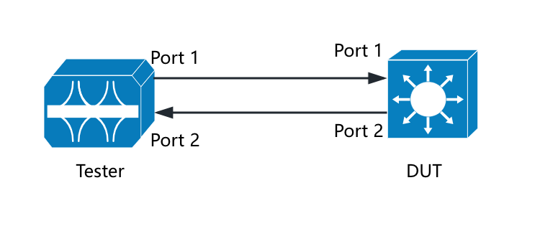
Pre-condition | 1. Switch can forward non-LLR frames normally without packet loss  2. Enable LLR on tester port 1 and port 2  3. Enable LLR on DUT port 1 and port 2  4. Create LLR flow on tester with 64B frame size  5. Clear counters on DUT and tester
Test Steps | 1. Check LLR state machine on DUT ports and tester ports, result 1  2. Send 100 LLR frames from tester with 100% line rate  3. Check DUT counters on Port 1, result 2  4. Check DUT counters on Port 2, result 3  5. Check tester Tx and Rx counters, result 4
Expectation | Result 1,  State machines are ADVANCE both on DUT and tester  Result 2,  Rx LLR frames = 100 on DUT Port 1  Result 3,  Tx LLR frames = 100 on DUT Port 2  Result 4,  LLR Tx frames on tester Port 1 = LLR Rx frames on DUT Port 1  LLR Rx frames on tester Port 2 = LLR Tx frames on DUT Port 2
Test Results | Result 1,  DUT Port 1: UEC_LLR_TX_ACTIVE=1; UEC_LLR_RX_ACTIVE=1;  DUT Port 2: UEC_LLR_TX_ACTIVE=1; UEC_LLR_RX_ACTIVE=1;  State Machine on tester is ADVANCE.  Result 2,  SAI_PORT_STAT_LLR_RX_OK=0x64(100) on DUT Port 1  Result 3,  SAI_PORT_STAT_LLR_TX_OK=0x64(100) on DUT Port 2  Result 4,  Tester LLR_Tx_OK= 100 on Port 1  Tester LLR_Rx_OK= 100 on Port 2  LLR_Tx_OK on tester Port 1 = SAI_PORT_STAT_LLR_RX_OK on DUT Port 1  LLR_Rx_OK on tester Port 2 = SAI_PORT_STAT_LLR_TX_OK on DUT Port 2
Comments

Case ID | LLR-002
Test Goal | NACK generation (frame loss and bad CRC)
Topo
Pre-condition | 1. Switch can forward non-LLR frames normally without packet loss  2. Enable LLR on tester port 1 and port 2  3. Enable LLR on DUT port 1 and port 2  4. Create LLR flow on tester with 64B frame size  5. Clear counters on DUT and tester  6. Check LLR state machine on DUT and tester are ADVANCE
Test Steps | 1. Send 1000 LLR frames with 100% line rate and simulate sequence gap 1 at the position 901  2. Check counters on DUT Port 1, result 1  3. Check counters on tester Port 1, result 2  4. Send 1000 LLR frames with 100% line rate and simulate 1 bad CRC frame at position 901 on tester Port 1  5. Check counters on DUT Port 1, result 3  6. Check counters on tester Port 1, result 4
Expectation | Result 1,  DUT Port 1: Tx NACK = 1, Rx replay event = 1, Rx LLR frames = 1100, Rx LLR OK frames = 1000, Rx error seq = 100  Result 2,  Tester Port 1: Rx NACK = 1, Tx replay event = 1, Tx replayed frames = 100, Tx Seq = 1000, Rx LLR frames = 1000, all received LLR frames are not out-of-order  Result 3,  DUT Port 1: Tx NACK = 1, Rx replay event = 1, Rx LLR frames = 1100, Rx LLR OK frames = 1000, Rx error seq = 99, Rx CRC error packet = 1  Result 4,  Tester Port 1: Rx NACK = 1, Tx replay event = 1, Tx replayed frames = 100, Tx Seq = 1000, Rx LLR frames = 1000, all received LLR frames are not out-of-order
Test Results | Result 1,  SAI_PORT_STAT_LLR_TX_NACK_CTL_OS=1, SAI_PORT_STAT_LLR_RX_REPLAY=1, UEC_LLR_RX_ELIGIBLE_FRAMES =0x44c(1100), SAI_PORT_STAT_LLR_RX_OK=0x3e8(1000), UEC_LLR_RX_UNEXPECTED_SEQ=0x64(100)  Result 2,  LLR_Rx_NACK_Ctl_OS = 1, LLR_Tx_REPLAY = 1, LLR_Tx_REPLAYED_FRAMES = 100, LLR_TX_NEXT_SEQ (UEC) = 1000, LLR_Rx_OK = 1000, LLR_Rx_EXPECTED_SEQ_GOOD = 1000  Result 3,  SAI_PORT_STAT_LLR_TX_NACK_CTL_OS=1, SAI_PORT_STAT_LLR_RX_REPLAY=1, UEC_LLR_RX_ELIGIBLE_FRAMES=0x44c(1100), SAI_PORT_STAT_LLR_RX_OK=0x3e8(1000), UEC_LLR_RX_UNEXPECTED_SEQ=0x63(99), SAI_PORT_STAT_LLR_RX_EXPECTED_SEQ_BAD=1  Result 4,  LLR_Rx_NACK_Ctl_OS = 1, LLR_Tx_RETRY_COUNT = 1, LLR_Tx_REPLAYED_FRAMES = 100, LLR_TX_NEXT_SEQ (UEC) = 1000, LLR_Rx_OK = 1000, LLR_Rx_CRC_Good = 1000
Comments

Case ID | LLR-003
Test Goal | Retry (NACK)
Topo
Pre-condition | 1. Switch can forward non-LLR frames normally without packet loss  2. Enable LLR on tester port 1 and port 2  3. Enable LLR on DUT port 1 and port 2  4. Create LLR flow on tester with 64B frame size  5. Clear counters on DUT and tester  6. Check LLR state machine on DUT and tester are ADVANCE
Test Steps | 1. Send 100 LLR frames with 100% line rate  2. Drop 1 frame at position 91 on tester Port 2  3. Check counters on DUT Port 2, result 1  4. Check counters on tester Port 2, result 2
Expectation | Result 1,  Rx NACK CtlOS = 1, Tx NACK replay event = 1, Tx replayed packets = 10  Result 2,  LLR Rx NACK CtlOS = 1, LLR Rx Retry Event = 1, Rx LLR replayed frames = 10, LLR Rx frames = 109, LLR Next Seq = 100
Test Results | Result 1,  SAI_PORT_STAT_LLR_RX_NACK_CTL_OS=1, SAI_PORT_STAT_LLR_RETRY_COUNT=1, UEC_LLR_REPLAYED_FRAMES=0xa(10)  Result 2,  LLR_Tx_NACK_Ctl_OS= 1, LLR_Rx_REPLAY = 1, LLR_Rx_REPLAYED_FRAMES = 10, LLR_Rx_OK = 109, LLR_RX_NEXT_SEQ (UEC) = 100
Comments

Case ID | LLR-004
Test Goal | Retry (Replay timer expired)
Topo
Pre-condition | 1. Switch can forward non-LLR frames normally without packet loss  2. Set DUT replay count max = 3  3. Set DUT replay timer to 0x8000  4. Disable re-init on discard on DUT and tester  5. Enable LLR on tester port 1 and port 2  6. Enable LLR on DUT port 1 and port 2  7. Create LLR flow on tester with 64B frame size  8. Clear counters on DUT and tester  9. Check LLR state machine on DUT and tester are ADVANCE
Test Steps | 1. Simulate ACKs continuously drop on tester Port 2  2. Send 100 LLR frames from tester with 100% line rate  3. Check counters on DUT Port 2, result 1  4. Check replayed packets on tester Port 2, result 2  5. Recover DUT state machine to ADVANCE  6. Simulate ACKs sequence freeze after 90 frames on tester Port 2  7. Send 100 LLR frames from tester with 100% line rate  8. Check counters on DUT Port 2, result 3  9. Check replayed packets on tester Port 2, result 4
Expectation | Result 1,  Tx timer replay event = 3, Tx packets = 400, Tx replayed packets = 300, Tx LLR OK = 100, state machine = FLUSH  Result 2,  Rx packets = 400, Rx replayed packets = 300  Result 3,  Tx timer replay event = 3, Tx replayed packets = 30, state machine = FLUSH  Result 4,  Rx packets = 130, Rx replayed packets = 30
Test Results | Result 1,  UEC_LLR_REPLAY_TIMER_EVENT=3, UEC_LLR_REPLAYED_FRAMES=0x12c(300), UEC_LLR_FLUSH_RETRY_COUNT=1, UEC_LLR_TX_ACTIVE=0/UEC_LLR_RX_ACTIVE=1  Result 2,  LLR_Rx_OK = 400, LLR_Rx_DUPLICATED_FRAMES = 300  Result 3,  UEC_LLR_REPLAY_TIMER_EVENT=3, UEC_LLR_REPLAYED_FRAMES=0x1e(30), UEC_LLR_FLUSH_RETRY_COUNT=1, UEC_LLR_TX_ACTIVE=0 UEC_LLR_RX_ACTIVE=1  Result 4,  LLR_Rx_OK = 130, LLR_Rx_DUPLICATED_FRAMES = 30
Comments

Case ID | LLR-005
Test Goal | Poison CRC Handling
Topo
Pre-condition | 1. Switch can forward non-LLR frames normally without packet loss  2. Set DUT to store forward mode  3. Enable LLR on tester port 1 and port 2  4. Enable LLR on DUT port 1 and port 2  5. Clear counters on DUT and tester  6. Check LLR state machine on DUT and tester are ADVANCE
Test Steps | 1. Create a LLR flow with 64B frame size  2. Send 100 LLR frames with 100% line rate and simulate 1 poison CRC frame at position 91 from tester Port 1  3. Check counters on DUT Port 1 and Port 2, result 1  4. Check counters on tester Port 1 and Port 2, result 2  5. Clear the counters on DUT and tester  6. Create a LLR flow with 9216B frame size  7. Send 100 LLR frames with 100% line rate and simulate 1 poison CRC frame at position 91 from tester Port 1  8. Check counters on DUT Port 1 and Port 2, result 3  9. Check counters on tester Port 1 and Port 2, result 4
Expectation | Result 1,  On Port 1: Tx NACK = 0, Rx replay event = 0, Rx poison CRC = 1, Rx LLR frames = 99, Rx LLR Eligible packets = 100  On Port 2: Rx NACK = 0, Tx replay event = 0, Tx LLR frames = 99, Tx LLR Eligible packets = 99  Result 2,  On Port 1: Rx NACK = 0, Tx replay event = 0, Tx replayed frames = 0, Tx Seq = 100, Tx LLR frames = 99  On Port 2: Rx LLR frames = 99, Rx LLR frames Good Seq = 99, Rx LLR Next Seq = 100  Result 3,  On Port 1: Tx NACK = 0, Rx replay event = 0, Rx poison CRC = 1, Rx LLR frames = 99, Rx LLR Eligible packets = 100  On Port 2: Rx NACK = 1, Tx NACK replay event = 1, Tx LLR frames = 99  Result 4,  On Port 1: Rx NACK = 0, Tx replay event = 0, Tx replayed frames = 0, Tx Seq = 100, Tx LLR frames = 99  On Port 2: Rx LLR frames = 99, Rx LLR frames Good Seq = 99, Rx LLR Next Seq = 100
Test Results | Result 1,  On Port 1: SAI_PORT_STAT_LLR_TX_NACK_CTL_OS=0, SAI_PORT_STAT_LLR_RX_REPLAY=0, SAI_PORT_STAT_LLR_RX_EXPECTED_SEQ_POISONED=1, UEC_LLR_RX_EXPECTED_SEQ_GOOD=0x63(99), SAI_PORT_STAT_LLR_RX_EXPECTED_SEQ_BAD=0, SAI_PORT_STAT_LLR_RX_OK=0x63(99), UEC_LLR_RX_ELIGIBLE_FRAMES=0x64(100)  On Port 2: SAI_PORT_STAT_LLR_RX_NACK_CTL_OS=0, SAI_PORT_STAT_LLR_RETRY_COUNT=0, UEC_LLR_REPLAYED_FRAMES=0, SAI_PORT_STAT_LLR_TX_OK=0x63(99), UEC_LLR_TX_ELIGIBLE_FRAMES=0x63(99)  Result 2,  On Port 1: LLR_Rx_NACK_Ctl_OS = 0, LLR_Tx_REPLAY = 0, LLR_Tx_REPLAYED_FRAMES = 0, LLR_TX_NEXT_SEQ (UEC) = 100, LLR_Tx_OK = 99  On Port 2: LLR_Rx_OK = 99, LLR_Rx_EXPECTED_SEQ_GOOD = 99, LLR_RX_NEXT_SEQ (UEC) = 100  Result 3,  On DUT Port 1  SAI_PORT_STAT_LLR_TX_NACK_CTL_OS=0, SAI_PORT_STAT_LLR_RX_REPLAY=0, SAI_PORT_STAT_LLR_RX_EXPECTED_SEQ_POISONED=1, UEC_LLR_RX_EXPECTED_SEQ_GOOD=0x63(99), SAI_PORT_STAT_LLR_RX_EXPECTED_SEQ_BAD=0, UEC_LLR_RX_ELIGIBLE_FRAMES=0x64(100)  On Port 2: SAI_PORT_STAT_LLR_RX_NACK_CTL_OS=0, SAI_PORT_STAT_LLR_RETRY_COUNT=0, UEC_LLR_TX_ELIGIBLE_FRAMES=0x63(99)  Result 4,  On Port 1: LLR_Rx_NACK_Ctl_OS = 0, LLR_Tx_REPLAY = 0, LLR_Tx_REPLAYED_FRAMES = 0, LLR_TX_NEXT_SEQ (UEC) = 100, LLR_Tx_OK = 99  On Port 2: LLR_Rx_OK = 99, LLR_Rx_EXPECTED_SEQ_GOOD = 99, LLR_RX_NEXT_SEQ (UEC) = 100
Comments

Case ID | LLR-006
Test Goal | OUTSTANDING_SEQ_MAX Limit
Topo
Pre-condition | 1. Switch can forward non-LLR frames normally without packet loss  2. Enable LLR on tester port 1 and port 2  3. Set replay count max = 1, outstanding frames max = 4, outstanding data max = 0xffff  4. Disable re-init on discard on DUT and tester  5. Enable LLR on DUT port 1 and port 2  6. Clear counters on DUT and tester  7. Check LLR state machine on DUT and tester are ADVANCE
Test Steps | 1. Simulate ACKs continuously drop on tester Port 2  2. Create LLR flow with 64B frame size  3. Send 100 LLR frames from tester with 100% line rate  4. Check counters on DUT Port 2, result 1  5. Check counters on tester Port 2, result 2  6. Clear the counters on DUT and tester  7. Create LLR flow with 9216B frame size  8. Send 100 LLR frames from tester with 100% line rate  9. Check counters on DUT Port 2, result 3  10. Check counters on tester Port 2, result 4
Expectation | Result 1,  Tx LLR frames >= 4, Tx timer replay event = 1, Tx replayed packets >=4, state machine = FLUSH  Result 2,  Rx replayed packets >= 4  Result 3,  Tx LLR frames >= 4, Tx timer replay event = 1, Tx replayed packets >=4, state machine = FLUSH  Result 4,  Rx replayed packets >= 4  Actual outstanding sequence max might be violated by a small amount, based on the inflight data.
Test Results | Result 1,  UEC_LLR_REPLAY_TIMER_EVENT=1, UEC_LLR_REPLAYED_FRAMES=9, UEC_LLR_TX_ACTIVE=0, UEC_LLR_RX_ACTIVE=1  Result 2,  LLR_Rx_DUPLICATED_FRAMES = 9, LLR_Rx_OK = 18  Result 3,  UEC_LLR_REPLAY_TIMER_EVENT=1, UEC_LLR_REPLAYED_FRAMES=5, UEC_LLR_TX_ACTIVE=0, UEC_LLR_RX_ACTIVE=1  Result 4,  LLR_Rx_DUPLICATED_FRAMES = 5, LLR_Rx_OK = 10
Comments

Case ID | LLR-007
Test Goal | Buffer Capacity
Topo
Pre-condition | 1. Switch can forward non-LLR frames normally without packet loss  2. Enable LLR on tester port 1 and port 2  3. Enable LLR on DUT port 1 and port 2  4. Clear counters on DUT and tester  5. Check LLR state machine on DUT and tester are ADVANCE
Test Steps | 1. Set OUTSTANDING_DATA_MAX = 0x4600  2. Calculate the simulated CtlOS delay time based on fiber length as formula:  $${Delay}_{s}(ns)=2×5×(500-d_{fl})$$  3. Set 4900ns CtlOS delay based on the result of the formula  4. Send 10000 LLR frames at 9216B from tester with 100% line rate  5. Check counters on tester Port 1 and Port 2, result 1  6. Send LLR frames flow at 9216B continuously from tester with 100% line rate for 1 minute  7. Check Rx rate on tester, result 2  8. Clear counters on DUT and tester  9. Repeat step 3-4 at 64B frame size, result 3  10. Repeat step 5-6 at 64B frame size, result 4
Expectation | Result 1,  Tx LLR frames = 10000, Rx LLR frames = 10000, no packet drop  Result 2,  Rx rate is not less than 99.5% line rate  Result 3,  Tx LLR frames = 10000, Rx LLR frames = 10000, no packet drop  Result 4,  Rx rate is not less than 99.5% line rate
Test Results | Result 1,  LLR_Tx_OK = 10000, LLR_Rx_OK = 10000, LLR_RX_NEXT_SEQ (UEC) = 10000, no packet drops  Result 2,  Tx rate = Rx rate = 398.447 Gbps. L1 line rate is 99.611%. No packet drops  Result 3,  LLR_Tx_OK = 10000, LLR_Rx_OK = 10000, LLR_RX_NEXT_SEQ (UEC) = 10000, no packet drops  Result 4,  Tx rate = Rx rate = 398.447 Gbps. L1 line rate is 99.616%. No packet drops
Comments

Case ID | LLR-008
Test Goal | Flush Recovery
Topo
Pre-condition | 1. Switch can forward non-LLR frames normally without packet loss  2. Enable LLR on tester port 1 and port 2  3. Enable LLR on DUT port 1 and port 2  4. Set DUT replay count max = 3  5. Enable re-init on discard on DUT and tester  6. Clear counters on DUT and tester  7. Check LLR state machine on DUT and tester are ADVANCE
Test Steps | 1. Simulate ACKs continuously drop on tester Port 2  2. Send 100 LLR frames from tester with 100% line rate  3. Check counters on DUT Port 2, result 1  4. Check counters on tester Port 2, result 2  5. Disable ACKs continuously drop on tester Port 2  6. Send 100 LLR frames from tester with 100% line rate  7. Check counters on DUT Port 2, result 3  8. Check counters on tester Port 2, result 4
Expectation | Result 1,  Tx timer replay event = 3, Tx replayed packets = 300, Tx FLUSH retry count = 1, state machine = ADVANCE  Result 2,  Tx LLR frames = 100, Rx LLR frames = 400, Rx LLR Duplicate Seq = 300  Result 3,  Tx timer replay event = 3(not increased), Tx replayed packets = 300(not increased), state machine = ADVANCE  Result 4,  Tx LLR frames = 100, Rx LLR frames = 100, no replayed packets
Test Results | Result 1,  UEC_LLR_REPLAY_TIMER_EVENT=3, UEC_LLR_REPLAYED_FRAMES=0x12c(300), UEC_LLR_FLUSH_RETRY_COUNT=1, UEC_LLR_TX_ACTIVE=1, UEC_LLR_RX_ACTIVE=1  Result 2,  LLR_Tx_OK = 100, LLR_Rx_OK = 400, LLR_Rx_DUPLICATED_FRAMES = 300, LLR_Rx_EXPECTED_SEQ_GOOD = 100  Result 3,  UEC_LLR_REPLAY_TIMER_EVENT=3, UEC_LLR_REPLAYED_FRAMES=0x12c(300), UEC_LLR_FLUSH_RETRY_COUNT=0, UEC_LLR_TX_ACTIVE=1, UEC_LLR_RX_ACTIVE=1  Result 4,  LLR_Tx_OK = 100, LLR_TX_NEXT_SEQ (UEC) = 200, LLR_Rx_OK = 100, LLR_Rx_EXPECTED_SEQ_GOOD = 100, no replayed packets
Comments

Case ID | LLR-009
Test Goal | Packet Size Traversal
Topo
Pre-condition | 1. Switch can forward non-LLR frames normally without packet loss  2. Enable LLR on tester port 1 and port 2  3. Enable LLR on DUT port 1 and port 2  4. Clear counters on DUT and tester  5. Check LLR state machine on DUT and tester are ADVANCE
Test Steps | 1. Set DUT OUTSTANDING_SEQ_MAX=0x7FF  2. Send LLR frames flow at Y+x bytes continuously from tester with 100% line rate for 20 minutes  3. Check flow statistics on tester, result 1  4. Repeat step 2-3 for below Y and x matrix  Y: 64, 128, 256, 512, 1518, 2048, 4096, 9216  x: 0, +1, -1 (for Y=64, x != -1, for Y=9216, x != +1)
Expectation | Result 1,  no packet loss, Rx rate is about 99.5%
Test Results | Result 1,  no packet loss on all frame sizes, Rx rate = 398Gbps  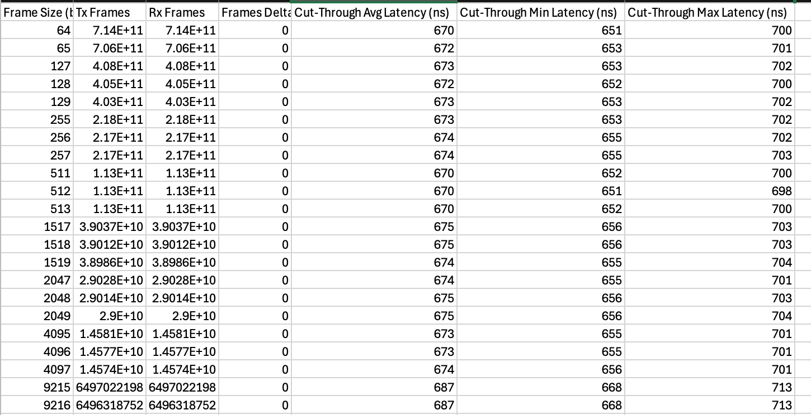  Latency calibration  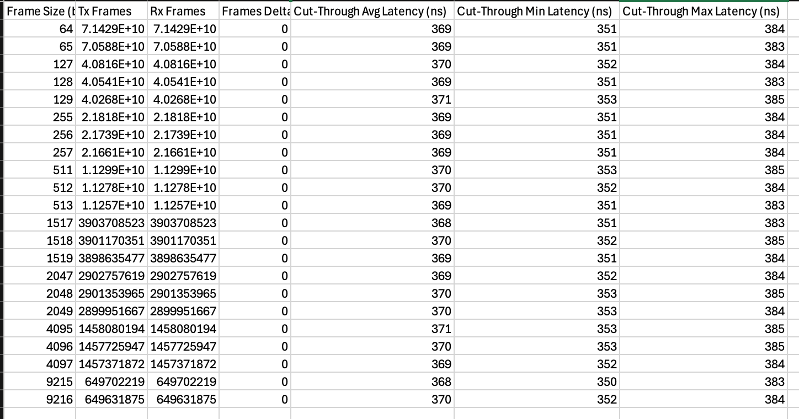
Comments

Case ID | LLR-010
Test Goal | Handling of LLR and non-LLR Frames together
Topo
Pre-condition | 1. Switch can forward non-LLR frames normally without packet loss  2. Enable LLR on tester port 1  3. Enable LLR on DUT port 1  4. Clear counters on DUT and tester  5. Check LLR state machine on DUT and tester are ADVANCE  6. Set DUT to store forward mode
Test Steps | 1. Create LLR-eligible and LLR-ineligible flows with the same frame format, set frame size = 1518, LLR-eligible flow = 95% line rate, LLR-ineligible flow = 5% line rate  2. Set replay count max to 3 on tester Port 1  3. Send 60s LLR and non-LLR frames from tester  4. Check flow counters on tester, result 1  5. Insert BER 1x$e^{-8}$ and distribution 100% on tester Port 1  6. Send 60s LLR-eligible and LLR-ineligible flows from tester  7. Check flow counters on tester, result 2
Expectation | Result 1,  No frame loss for LLR-eligible flow and LLR-ineligible flow  The latency for LLR-eligible flow and LLR-ineligible flow should be very close  Result 2,  Non-LLR flow should have some packets drop  LLR flow should have some retry and should have no packet drop
Test Results | Result 1,  No frame loss for LLR-eligible and LLR-ineligible flows  LLR-eligible flow: Avg(650ns) | Min(632ns) | Max(675ns)  LLR-ineligible flow: Avg(650ns) | Min(633ns) | Max(674ns)  Result 2,  No frame loss for LLR-eligible flow  Has some frames loss for LLR-ineligible flow
Comments

Case ID | CBFC-001
Test Goal | Sender Credit Handling
Topo | 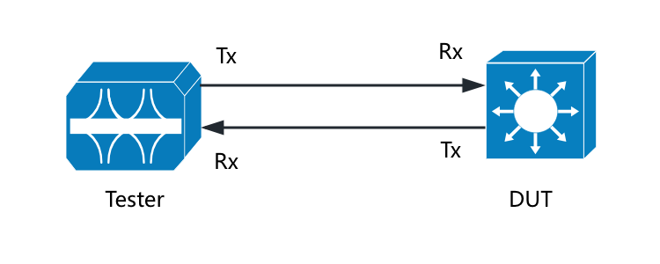
Pre-condition | 1. Enable CBFC on DUT ports and tester ports  2. Create 1 lossless VC0 on tester and DUT  3. Set credit mode to per VC on tester and DUT  4. Set credit size to 56 on tester and DUT  5. Set overhead to 16 on tester Tx port and overhead to 0 on tester Rx port  6. Set credits limit per VC to 10000 on tester Tx port and 10000 on tester Rx port  7. Set credits limit per VC to 10000 on DUT Rx port and 10000 on DUT Tx port  8. Disable CC_Update on DUT Tx port  9. Stop sending CF_Update on tester Rx port  10. Clear the counters on tester and DUT
Test Steps | 1. Create a flow at Y+x bytes with 100% line rate  2. Send this flow with 10 frames on VC0  3. Check the counters on DUT Tx port, result 1  4. Repeat step 2-3 for below Y and x matrix  5. Resume sending CF_Update on tester Rx port  6. Clear the counters on DUT and tester  7. Send this flow with 10 frames on VC0  8. Check the counters on DUT Tx port, result 2  9. Repeat step 8-9 for below Y and x matrix  Y: 64, 128, 256, 512, 1518, 2048, 4096, 9216  x: 0, +1, -1 (for Y=64, x != -1, for Y=9216, x != +1)
Expectation | $$pktCredits=roundup({(pktSize+pktOvhd)}/{CreditSize})$$  Result 1,  SENDER_CREDITS_USED, SENDER_CREDITS_CONSUMED matches theoretical formula  Result 2,  SENDER_CREDITS_FREED matches theoretical formula and SENDER_CREDITS_CONSUMED should be 0
Test Results | Result 1,  The counters on all frame sizes match theoretical formula  R_VC_CC[0] = 8050, R_VC_CF[0] = 8050 on tester Port2  Result 2,  The counters on all frame sizes match theoretical formula. SAI_VIRTUAL_CHANNEL_STAT_SENDER_CREDITS_CONSUMED in DUT is 0.  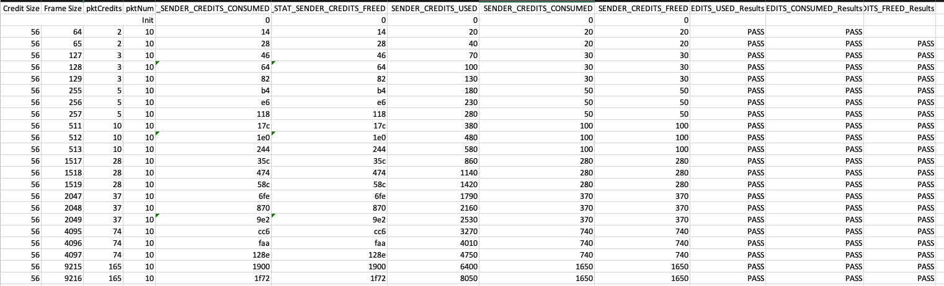
Comments

Case ID | CBFC-002
Test Goal | Receiver Credit Handling
Topo
Pre-condition | 1. Enable CBFC on DUT ports and tester ports  2. Create 1 lossless VC0 on tester and DUT  3. Set credit mode to per VC on tester and DUT  4. Set credit size to 56 on tester and DUT  5. Set overhead to 16 on tester Tx port and overhead to 0 on tester Rx port  6. Set credits limit per VC to 10000 on tester Tx port and 10000 on tester Rx port  7. Set credits limit per VC to 10000 on DUT Rx port and 10000 on DUT Tx port  8. Stop sending CC_Update on tester Tx port  9. Clear the counters on tester and DUT
Test Steps | 1. Create a flow at Y+x bytes with 100% line rate  2. Send flow with 10 frames on VC0  3. Check the counters on DUT Rx port, result 1  4. Repeat step 2-3 for below Y and x matrix  5. Check the counter on tester Tx port, result 2  Y: 64, 128, 256, 512, 1518, 2048, 4096, 9216  x: 0, +1, -1 (for Y=64, x != -1, for Y=9216, x != +1)
Expectation | $$pktCredits=roundup({(pktSize+pktOvhd)}/{CreditSize})$$  Result 1,  RECEIVER_CREDITS_FREED matches theoretical formula  Result 2,  SAI_VIRTUAL_CHANNEL_STAT_SENDER_CREDITS_FREED on tester = CF send counter in DUT Rx port = SAI_VIRTUAL_CHANNEL_STAT_SENDER_CREDITS_CONSUMED on tester  RECEIVER_CREDITS_CONSUMED matched theoretical formula
Test Results | Result 1,  The counters on all frame sizes match theoretical formula  Result 2,  The counters on all frame sizes match theoretical formula  S_VC_CC[0] = 8050, S_VC_CF[0] = 8050 on tester Port 1  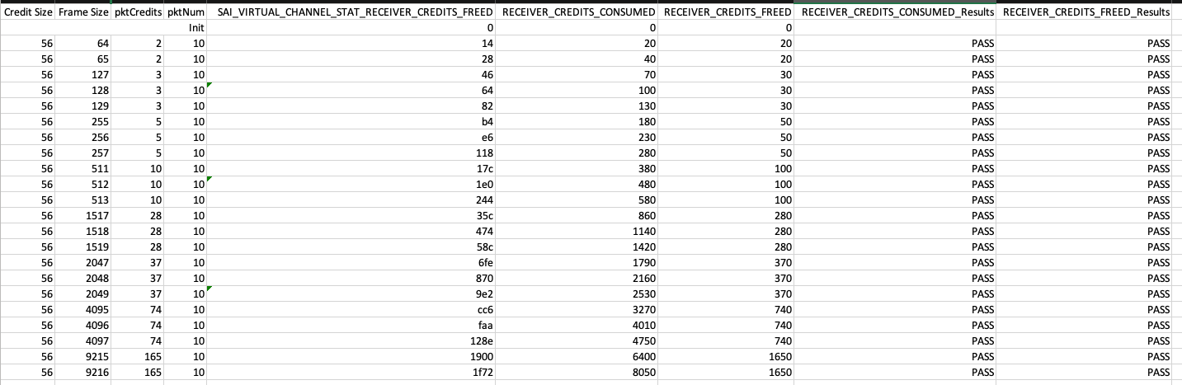
Comments

Case ID | CBFC-003
Test Goal | Credit Loss/Recovery
Topo
Pre-condition | 1. Enable CBFC on DUT ports and tester ports  2. Create 1 lossless VC0 on tester and DUT  3. Set credit mode to per VC on tester and DUT  4. Set credit size to 56 on tester and DUT  5. Set overhead to 16 on tester Tx port and overhead to 0 on tester Rx port  6. Set credits limit per VC to 10000 on tester Tx port and 10000 on tester Rx port  7. Set credits limit per VC to 10000 on DUT Rx port and 10000 on DUT Tx port  8. Clear the counters on tester and DUT
Test Steps | 1. Create a flow with 1518B frame size  2. Stop sending CC_Update on tester Tx port  3. Send 100 corrupted packets  4. Check counters on DUT Rx port and tester Tx port, result 1  5. Resume CC_Update on tester Tx port  6. Check counters on DUT Rx port and tester Tx port, result 2
Expectation | Result 1,  RECEIVER_CREDIT_CONSUMED = 0, RECEIVER_CREDIT_FREED = 0  Tester Tx port should receive CF_Update but the counters for SAI_VIRTUAL_CHANNEL_STAT_SENDER_CREDITS_FREED is not updated, S_P_CU on tester Tx port = 2800  Result 2,  DUT Rx port RECEIVER_CREDIT_CONSUMED = tester Tx port SAI_VIRTUAL_CHANNEL_STAT_SENDER_CREDITS_CONSUMED,  DUT Rx port RECEIVER_CREDIT_FREED = tester Tx port SAI_VIRTUAL_CHANNEL_STAT_SENDER_CREDITS_FREED,  Tester Tx port S_P_CU = 0
Test Results | Result 1,  SAI_VIRTUAL_CHANNEL_STAT_RECEIVER_CREDITS_FREED (VC0) CNT=0  S_VC_CC[0] = 2800, S_VC_CF[0] = 0, S_P_CU=2800 on tester Port 1  Result 2,  SAI_VIRTUAL_CHANNEL_STAT_RECEIVER_CREDITS_FREED (VC0) CNT=0xaf0(2800)  SAI_VIRTUAL_CHANNEL_STAT_RECEIVER_CREDITS_FREED (VC0) = SAI_VIRTUAL_CHANNEL_STAT_SENDER_CREDITS_FREED = SAI_VIRTUAL_CHANNEL_STAT_SENDER_CREDITS_CONSUMED  S_VC_CC[0] = 2800, S_VC_CF[0] = 2800, S_P_CU = 0 on tester Port 1
Comments

Case ID | CBFC-004
Test Goal | Backpressure
Topo
Pre-condition | 1. Enable CBFC on DUT ports and tester ports  2. Create 1 lossless VC0 on tester and DUT  3. Set credit mode to per VC on tester and DUT  4. Set credit size to 56 on tester and DUT  5. Set overhead to 16 on tester Tx port and overhead to 0 on tester Rx port  6. Set credits limit per VC to 10000 on tester Tx port and 10000 on tester Rx port  7. Set credits limit per VC to 10000 on DUT Rx port and 10000 on DUT Tx port  8. Set drain rate to 20% on tester Rx port  9. Clear the counters on tester and DUT
Test Steps | 1. Create a flow at Y+x bytes with 100% line rate  2. Send this flow on VC0 continuously  3. Set drain rate to maximum on tester Rx port  4. Check the throughput on tester, result 1  5. Set drain rate to 0% on tester Rx port  6. Check the throughput on tester, result 2  7. Set drain rate to 50% on tester Rx port  8. Check the throughput on tester, result 3  9. Repeat step 1-8 for below Y and x matrix  Y: 64, 128, 256, 512, 1518, 2048, 4096, 9216  x: 0, +1, -1 (for Y=64, x != -1, for Y=9216, x != +1)
Expectation | $$pktCredits=roundup({(pktSize+pktOvhd)}/{CreditSize})$$  Result 1,  Throughput is ≥ 99% and no packet drop  Result 2,  Throughput is ~ 0% and traffic stops  Result 3,  Throughput is ~ 50% and no packet drop
Test Results | Result 1,  Throughput is ≥ 99% and no packet drop  Result 2,  Throughput is ~ 0% and traffic stops  Result 3,  Throughput is ~ 50% and no packet drop
Comments

Case ID | CBFC-005
Test Goal | VLAN PCP+DEI Mapping
Topo
Pre-condition | 1. Enable CBFC on DUT ports and tester ports  2. Create 2 lossless VC0 and VC7 on DUT and tester  3. Set credit mode to per VC on tester and DUT  4. Set credit size to 56 on tester and DUT  5. Set overhead to 16 on tester Tx port and overhead to 0 on tester Rx port  6. Set credits limit per VC to 10000 on tester Tx port and 10000 on tester Rx port  7. Set credits limit per VC to 10000 on DUT Rx port and 10000 on DUT Tx port  8. Config DUT maps PCP=3 and DEI=1 into VC7  9. Config tester Rx port maps PCP=3 and DEI=1 into VC7  10. Stop sending CF_Update on tester Rx port and stop sending CC_Update on tester Tx port
Test Steps | 1. Create a flow with 1518B frame size with VLAN PCP 3 and DEI  2. Send 100 frames via VC0 from tester Tx port  3. Check counters on DUT Tx port, result 1  4. Check counters on tester Rx port, result 2
Expectation | Result 1,  Has SENDER_CREDITS_USED counter on VC7, DUT forwards the frames on VC7  Result 2,  Has SAI_VIRTUAL_CHANNEL_STAT_RECEIVER_CREDITS_CONSUMED and SAI_VIRTUAL_CHANNEL_STAT_RECEIVER_CREDITS_FREED on VC7 counter, no packet drop
Test Results | Result 1,  SAI_VIRTUAL_CHANNEL_STAT_SENDER_CREDITS_CONSUMED (VC7) =0xaf0(2800)  SAI_QUEUE_STAT_PACKETS (VC7-mapped queue) : 100 +100  SAI_QUEUE_STAT_BYTES (VC7-mapped queue) : 151,800 +151,800  Result 2,  R_VC_CC[7] = 2800, R_VC_CF[7] = 2800, no packet drop on tester Port 2
Comments

Case ID | CBFC-006
Test Goal | IPv4 DSCP Mapping
Topo
Pre-condition | 1. Enable CBFC on DUT ports and tester ports  2. Create 2 lossless VC0 and VC7 on DUT and tester  3. Set credit mode to per VC on tester and DUT  4. Set credit size to 56 on tester and DUT  5. Set overhead to 16 on tester Tx port and overhead to 0 on tester Rx port  6. Set credits limit per VC to 10000 on tester Tx port and 10000 on tester Rx port  7. Set credits limit per VC to 10000 on DUT Rx port and 10000 on DUT Tx port  8. Config DUT maps DSCP 7 into VC7  9. Config tester Rx port DSCP 7 into VC7  10. Stop sending CF_Update on tester Rx port and stop sending CC_Update on tester Tx port
Test Steps | 1. Create a flow with 1518B frame size with DSCP 7  2. Send 100 frames via VC0 from tester Tx port  3. Check counters on DUT Tx port, result 1  4. Check counters on tester Rx port, result 2
Expectation | Result 1,  Has SENDER_CREDITS_USED on VC7 counter, DUT forwards the frames on VC7  Result 2,  Has SAI_VIRTUAL_CHANNEL_STAT_RECEIVER_CREDITS_CONSUMED and SAI_VIRTUAL_CHANNEL_STAT_RECEIVER_CREDITS_FREED on VC7 counter, no packet drops
Test Results | Result 1,  SAI_VIRTUAL_CHANNEL_STAT_SENDER_CREDITS_CONSUMED (VC7) =0xaf0(2800)  SAI_QUEUE_STAT_PACKETS (VC7-mapped queue) : 100 +100  SAI_QUEUE_STAT_BYTES (VC7-mapped queue) : 151,800 +151,800  Result 2,  R_VC_CC[7] = 2800, R_VC_CF[7] = 2800, no packet drop on tester Port 2
Comments

Case ID | CBFC-007
Test Goal | IPv6 DSCP Mapping
Topo
Pre-condition | 1. Enable CBFC on DUT ports and tester ports  2. Create 2 lossless VC0 and VC7 on DUT and tester  3. Set credit mode to per VC on tester and DUT  4. Set credit size to 56 on tester and DUT  5. Set overhead to 16 on tester Tx port and overhead to 0 on tester Rx port  6. Set credits limit per VC to 10000 on tester Tx port and 10000 on tester Rx port  7. Set credits limit per VC to 10000 on DUT Rx port and 10000 on DUT Tx port  8. Config DUT maps DSCP 7 into VC7  9. Config tester Rx port DSCP 7 into VC7  10. Stop sending CF_Update on tester Rx port and stop sending CC_Update on tester Tx port
Test Steps | 1. Create a flow with 1518B frame size with DSCP 7  2. Send 100 frames via VC0 from tester Tx port  3. Check counters on DUT Tx port, result 1  4. Check counters on tester Rx port, result 2
Expectation | Result 1,  Has SENDER_CREDITS_USED on VC7 counter, DUT forwards the frames on VC7  Result 2,  Has SAI_VIRTUAL_CHANNEL_STAT_RECEIVER_CREDITS_CONSUMED and SAI_VIRTUAL_CHANNEL_STAT_RECEIVER_CREDITS_FREED on VC7 counter, no packet drops
Test Results | Result 1,  SAI_VIRTUAL_CHANNEL_STAT_SENDER_CREDITS_CONSUMED (VC7) =0xaf0(2800)  SAI_QUEUE_STAT_PACKETS (VC7-mapped queue) : 100 +100  SAI_QUEUE_STAT_BYTES (VC7-mapped queue) : 151,800 +151,800  TX_BYT_IPV6 : 151,800 +151,800  TX_PKT_IPV6 : 100 +100  Result 2,  R_VC_CC[7] = 2800, R_VC_CF[7] = 2800, no packet drop on tester Port 2
Comments

Case ID | CBFC-008
Test Goal | Per-VC Credit
Topo
Pre-condition | 1. Enable CBFC on DUT ports and tester ports  2. Create 4 lossless VC0, VC1, VC3, VC4 on tester and DUT  3. Set credit mode to per VC on tester and DUT  4. Set credit size to 56 on tester and DUT  5. Set overhead to 16 on tester Tx port and overhead to 0 on tester Rx port  6. Set credits limit per VC to 2500 on tester Tx port and 2500 on tester Rx port  7. Set credits limit per VC to 2500 on DUT Rx port and 2500 on DUT Tx port  8. Clear the counters on tester and DUT
Test Steps | 1. Create 4 lossless flows on each tester Tx port, with frame size 1518B and 25% line rate.  2. Set DSCP 0, 1, 3, 4 for each lossless flow per Tx port.  3. Set drain rate to 100% on tester Rx port for all VCs  4. Check the Tx frame rate and Rx frame rate on tester, result 1  5. Set drain rate 10% on VC1  6. Check the Tx frame rate and Rx frame rate for other VCs on tester, result 2  7. Set drain rate 0% on VC1  8. Check the Tx frame rate and Rx frame rate for other VCs on tester, result 3  9. Increase Tx rate of VC0 to 50% line rate  10. Check the Tx frame rate and Rx frame rate on tester, result 4
Expectation | Result 1,  All VCs have the same frame rate, expected rate is close to the configured line rate  Result 2,  VC1 Tx frame rate and Rx frame rate are decreased but other VCs are not impacted  Result 3,  VC1 Tx frame rate and Rx frame rate are 0 but other VCs are not impacted  Result 4,  VC0 Tx frame rate and Rx frame rate can be increased
Test Results | Result 1,  VC0 and VC1 have the same frame rate, Rx rate is 99.8823%, each VC rate is close to 25%  Result 2,  VC1 Tx frame rate and Rx frame rate are decreased, other VCs keep the Tx and Rx frame rate  Result 3,  VC1 Tx frame rate and Rx frame rate are 0, other VCs keep the Tx and Rx frame rate  Result 4,  VC0 Tx frame rate and Rx frame rate are increased to close to 50% line rate.
Comments

Case ID | CBFC-009
Test Goal | Per-Port Credit
Topo
Pre-condition | 1. Enable CBFC on DUT ports and tester ports  2. Create 2 lossless VC0 and VC1 on tester and DUT  3. Set credit mode to per port on tester and DUT  4. Set credit size to 56 on tester and DUT  5. Set overhead to 16 on tester Tx port and overhead to 0 on tester Rx port  6. Set total credits to 10000 on tester Tx port and 10000 on tester Rx port  7. Set total credits to 10000 on DUT Rx port and 10000 on DUT Tx port  8. Clear the counters on tester and DUT
Test Steps | 1. Create two flows at 1518bytes with 50% line rate for each  2. Send flow1 to VC0 flow2 to VC1  3. Set drain rate to 100% on tester Rx port for VC0 and VC1  4. Check the Tx frame rate and Rx frame rate on tester, result 1  5. Set drain rate 30% on VC1  6. Check the Tx frame rate and Rx frame rate on tester, result 2  7. Set drain rate 0% on VC1  8. Check the Tx frame rate and Rx frame rate on tester, result 3  9. Restore drain rate to 100% on VC1  10. Check the Tx frame rate and Rx frame rate on tester, result 4
Expectation | Result 1,  VC0 and VC1 have the same frame rate, expected rate is close to the configured line rate  Result 2,  VC1 and VC0 have the same frame rate but both are decreased  Result 3,  VC1 and VC0 are 0 frame rate  Result 4,  VC0 is recovered to configured line rate
Test Results | Result 1,  VC0 and VC1 have the same frame rate, Rx rate is 99.8814%, each VC rate is close to 50%  Result 2,  Tx and Rx frame rate of VC0 and VC1 are decreased and they are same  Result 3,  VC0 and VC1 are 0 frame rate  Result 4,  VC0 can recover its rate
Comments

Case ID | CBFC-010
Test Goal | N-to-1 incast with lossless traffic
Topo | 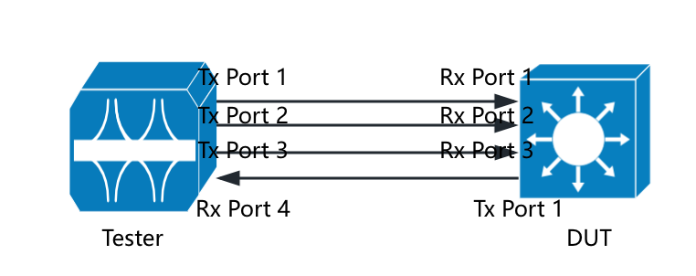
Pre-condition | 1. Enable CBFC on DUT ports and tester ports  2. Create 1 lossless VC0 on tester and DUT  3. Set credit mode to per VC on tester and DUT  4. Set credit size to 56 on tester and DUT  5. Set overhead to 16 on tester Tx port and overhead 0 on tester Rx port  6. Set credits limit per VC to 10000 on tester Tx port and 10000 on tester Rx port  7. Set credits limit per VC to 10000 on DUT Rx port and 10000 on DUT Tx port  8. Clear the counters on tester and DUT
Test Steps | 1. Create 1 lossless flows on each tester Tx port, with frame size 1518B and 100% line rate  2. Set DSCP 0 for VC0 per Tx port  3. Set drain rate to 100% on tester Rx port  4. Suspend all flows  5. Send flow from tester Tx Port 1, then Tx Port 2, then Tx Port 3  6. Check Tx rate and Rx rate, result 1  7. Suspend flows on Tx Port 3, then Tx Port 2  8. Check Tx rate and Rx rate, result 2  9. Stop flows and check packet drops, result 3
Expectation | Result 1,  With only Tx Port 1 sending flow, Tx rate and Rx rate is close to 100%  With Tx Port 1 and Tx Port 2 sending flow, the Tx rate distribution is even and Rx rate is close to 100%  With all Tx ports sending flow, the Tx rate distribution is even and Rx rate is close to 100%  Result 2,  Tx rate and Rx rate is close to 100%  Result 3,  No packet drops
Test Results | Result 1,  Tx rate is 99.8823%, Rx rate is 99.8824%. No congestion.  Tx rate is even when Tx Port 2 join sending. Each port is 49.95%.  Tx rate is even when Tx Port 3 join sending. Each one is 33.30%.  Result 2,  Tx rate is even when Tx Port 3 suspend sending. Each port is 49.95%.  Tx rate and Rx rate is 99.8823% after suspending Tx Port 2. No congestion.  Result 3,  Tx1 = 8718458062, Tx2 = 4113927340, Tx3 = 2383399879, Rx = 15215785281  Tx1 + Tx2 + Tx3 = Rx, no packet drops
Comments

Case ID | CBFC-011
Test Goal | N-to-1 Incast with lossless + best effort traffic
Topo
Pre-condition | 1. Enable CBFC on DUT ports and tester ports  2. Create 1 lossless VC0 on tester and DUT  3. Create 1 lossy VC4 on tester and DUT  4. Set credit mode to per VC on tester and DUT  5. Set credit size to 56 on tester and DUT  6. Set overhead to 16 on tester Tx port and overhead 0 on tester Rx port  7. Set credits limit per VC to 10000 on tester Tx port and 10000 on tester Rx port  8. Set credits limit per VC to 10000 on DUT Rx port and 10000 on DUT Tx port  9. Clear the counters on tester and DUT
Test Steps | 1. Create 1 lossless flow on each tester Tx port, with frame size 1518B, DSCP 0 and 50% line rate  2. Set DSCP 0 for VC0 per Tx port  3. Create 1 lossy flow on each tester Tx port, with frame size 1518B, DSCP 4 and 50% line rate  4. Set DSCP 4 for VC4 per Tx port  5. Set drain rate to 100% for VC0 on tester Rx port  6. Suspend VC4 flows then start to transmit all flows  7. Check the Tx rate and Rx rate on tester, result 1  8. Inject VC4 flow from Tx Port 1, then Tx Port 2, then Tx Port 3  9. Check Tx rate and Rx rate on tester, result 2  10. Stop flows and check packet drops, result 3
Expectation | Result 1,  Tx rate distribution is even among Tx Port 1, Tx Port 2 and Tx Port 3, Rx rate is close to 100%  Result 2,  Tx rate distribution is even among Tx Port 1, Tx Port 2 and Tx Port 3, Rx rate is close to 100%  Result 3,  VC0 has no packet drop, VC4 has packet drop
Test Results | Result 1,  Tx rate distribution is even among Tx Port 1, Tx Port 2 and Tx Port 3. Each of them is around 33.3%. Rx rate is 99.944%.  Result 2,  Tx rate distribution is even among Tx Port 1, Tx Port 2 and Tx Port 3. Each of them is around 66.67%. Rx rate is 99.944%  Result 3,  Tx frames on VC0 = 2,525,792,897 + 2,531,808,746 + 2,513,495,606 = 7,571,097,249  Rx frames on VC0 = 7,571,097,249  No packet drops on VC0(lossless)  Tx frames on VC4 = 2,428,347,765 + 1,675,494,960 + 1,616,366,478 = 5,720,209,203  Rx frames on VC4 = 2,426,589,068  Packet drops on VC4(lossy)
Comments

Case ID | CBFC-012
Test Goal | Buffer Capacity
Topo
Pre-condition | 1. Enable CBFC on DUT ports and tester ports  2. Create 1 lossless VC0 on tester and DUT  3. Set credit mode to per VC on tester and DUT  4. Set credit size to 56 on tester and DUT  5. Set overhead to 16 on tester Tx port and overhead 0 on tester Rx port  6. Disable CC_Update on tester and DUT  7. Clear the counters on tester and DUT
Test Steps | 1. Calculate the simulated CtlOS delay time based on fiber length as formula:  $${Delay}_{s}(ns)=2×5×(500-d_{fl})$$  2. Set 4900ns CF_Update delay based on the result of step 1(10m fiber length + 4900ns = 5000ns)  3. Calculate the theoretical credit limit based on the RTT delay  $CL={roundup(pktCredits ×Link Speed×(RTT_on_media + internal delay)}/{(8×pktSize }))$  $$pktCredits=roundup({(pktSize+pktOvhd)}/{CreditSize})$$  4. Set credits limit per VC to the 4476(without consider any internal delay) on tester Tx and Rx ports based on the result of step 3  5. Set credits limit per VC to the 4476(without consider any internal delay) on DUT Tx and Rx ports based on the result of step 3  6. Set drain rate to 100% on tester Rx port  7. Send lossless flow at 9216B continuously from tester with 100% line rate more than 1 minute  8. Check Rx rate on tester, result 1  9. Set credits limit per VC to the 6240(minimal CL consider internal delay) on tester Tx and Rx ports based on the result of step 3  10. Set credits limit per VC to the 6240(minimal CL consider internal delay) on DUT Tx and Rx ports based on the result of step 3  11. Set drain rate to 100% on tester Rx port  12. Send lossless flow at 9216B continuously from tester with 100% line rate more than 1 minute  13. Check Rx rate on tester, result 2  14. Set credits limit per VC to the 7813(without consider any internal delay) on tester Tx and Rx ports based on the result of step 3  15. Set credits limit per VC to the 7813(without consider any internal delay) on DUT Tx and Rx ports based on the result of step 3  16. Set drain rate to 133.33% on tester Rx port  17. Send lossless flow at 64B continuously from tester with 100% line rate more than 1 minute  18. Check Rx rate on tester, result 3  19. Set credits limit per VC to the 7825(minimal CL consider internal delay) on tester Tx and Rx ports based on the result of step 3  20. Set credits limit per VC to the 7825(minimal CL consider internal delay) on DUT Tx and Rx ports based on the result of step 3  21. Set drain rate to 133.33% on tester Rx port  22. Send lossless flow at 64B continuously from tester with 100% line rate more than 1 minute  23. Check Rx rate on tester, result 4  24. Clear the CtlOS delay on tester (by default 10m fiber length, 100ns)  25. Set credits limit per VC to the 157(without consider any internal delay) on tester Tx and Rx ports based on the result of step 3  26. Set credits limit per VC to the 157(without consider any internal delay) on DUT Tx and Rx ports based on the result of step 3  27. Set drain rate to 133.33% on tester Rx port  28. Send lossless flow at 64B continuously from tester with 100% line rate more than 1 minute  29. Check Rx rate on tester, result 5  30. Set credits limit per VC to the 1990(minimal CL consider internal delay) on tester Tx and Rx ports based on the result of step 3  31. Set credits limit per VC to the 1990(minimal CL consider internal delay) on DUT Tx and Rx ports based on the result of step 3  32. Set drain rate to 133.33% on tester Rx port  33. Send lossless flow at 64B continuously from tester with 100% line rate more than 1 minute  34. Check Rx rate on tester, result 6  35. Set credits limit per VC to the 1875(minimal CL consider internal delay) on tester Tx and Rx ports based on the result of step 3  36. Set credits limit per VC to the 1875(minimal CL consider internal delay) on DUT Tx and Rx ports based on the result of step 3  37. Set drain rate to 100% on tester Rx port  38. Send lossless flow at 9216B continuously from tester with 100% line rate more than 1 minute  39. Check Rx rate on tester, result 7
Expectation | Result 1,  Rx rate cannot be close to 100%, no packet drops  Result 2,  Rx rate is close to 100%, no packet drops  Result 3,  Rx rate cannot be close to 100%, no packet drops  Result 4,  Rx rate is close to 100%, no packet drops  Result 5,  Rx rate cannot be close to 100%, no packet drops  Result 6,  Rx rate is close to 100%, no packet drops  Result 7,  Rx rate is close to 100%, no packet drops
Test Results | Result 1,  Rx rate is 70.4996%, Tx frames = 246529230, Rx frames = 246529230, no packet drops  Result 2,  Rx rate is 99.6548%, Tx frames = 395438707, Rx frames = 395438707, no packet drops  Result 3,  Rx rate is 98.0948%, Tx frames = 62605297655, Rx frames = 62605297655, no packet drops  Result 4,  Rx rate is 99.9999%, Tx frames = 37559174057, Rx frames = 37559174057, no packet drops  Result 5,  Rx rate is 5.5863%, Tx frames = 2274075728, Rx frames = 2274075728, no packet drops  Result 6,  Rx rate is 99.9999%, Tx frames = 64434319261, Rx frames = 64434319261, no packet drops  Result 7,  Rx rate is 99.6543%, Tx frames = 394780941, Rx frames = 394780941, no packet drops
Comments | For 9216B, 6240 CL guarantees the line rate of 400Gbps on 500m  For 64B, 7825 CL guarantees the line rate of 400Gbps on 500m.  For 9216B, 1875 CL guarantees the line rate of 400Gbps on 10m  For 64B, 1990 CL guarantees the line rate of 400Gbps on 10m.

